**Create JUnit Script using Selenium IDE**We can record the test case using Selenium IDE & convert recorded script to Java WebDriver format & execute the automated test script using Eclipse. To start with you should have **Eclipse, Java** & **Firefox** installed on your machine.

1. We have recorded a Test case using in Selenium IDE recording feature.
2. “Enable Experimental Features” from Selenium IDE options & converted generated HTML code to JUnit 4/Java/WebDriver format.
3. In Eclipse, created “firstPackage” & Class under Selenium WebDriver project & pasted above automated generated code in class.
4. One by one resolved all error & warning messages observed in code.
5. **Record a Test case using in Selenium IDE.** Open Selenium IDE by selecting “Tools > Selenium IDE” option. In Selenium IDE the recording option is turned ON by-default.   
   Once the recording is done, the recorded command is noted in the command section. Turn off the recording option to stop recording and successfully recorded script in Selenium IDE.

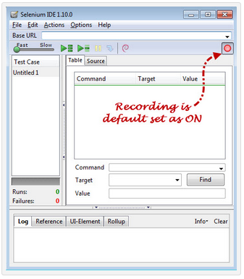 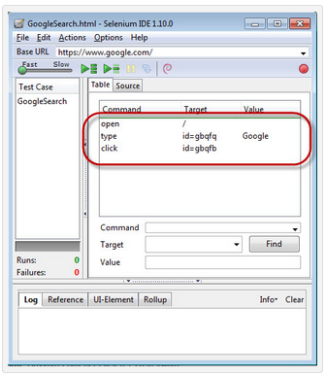

1. **Enable Experimental features** from Selenium IDE**.** Navigate to Options > Options > General

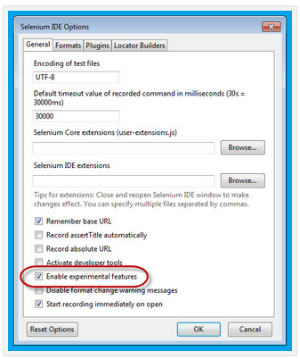

1. Navigate to Options > Format & select the “**Java/ Junit 4 / WebDriver**” option.

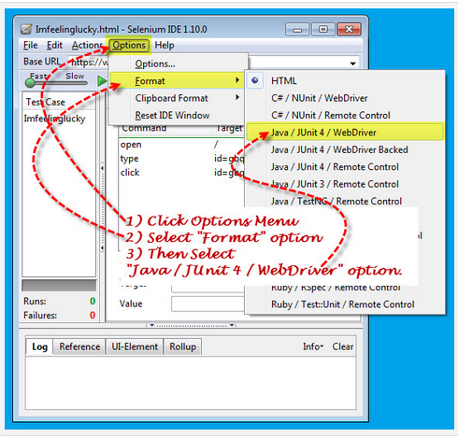

1. JavaScript Application dialog will be display. Click on OK button

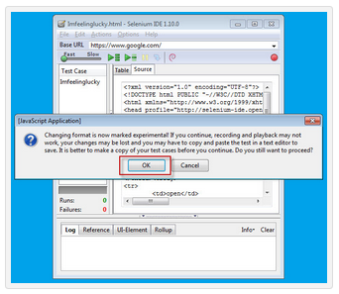

1. Java code is displayed in Selenium IDE – Source tab. This code will be used for creating Selenium WebDriver code.

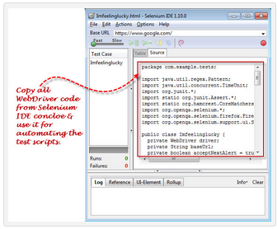

1. **Create “First package”** under Selenium WebDriver project. Launch Eclipse IDE & open project that is created before. In New Java Package dialog enter Name as “firstPackage”.

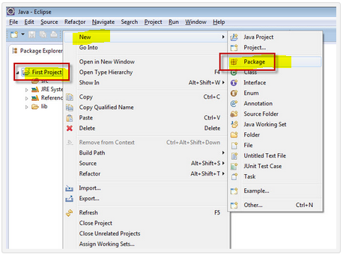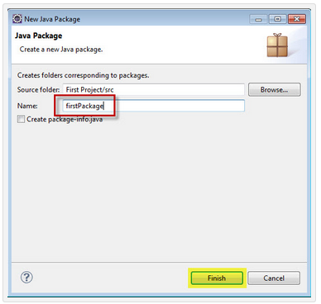

1. Once you created the first package, ensure that it is added under “src” folder.
2. Right click on newly created package “firstPackage” select option, New > Class.

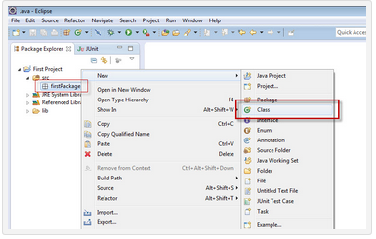

1. In New Java Class dialog box enter class name in Name text box as “GoogleSearch” shown. 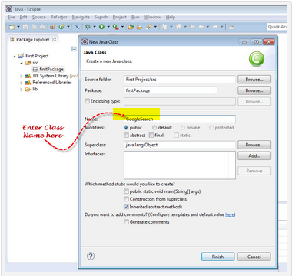
2. Once you created the “GoogleSearch” class, ensure that it is added under “firstPackage” folder.

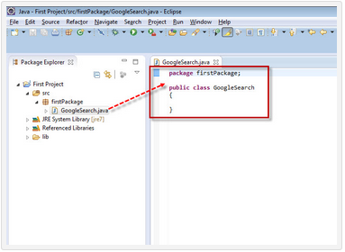

1. Now copy the Java/Junit4/WebDriver format converted code to from the previously recorded in Selenium IDE Source tab

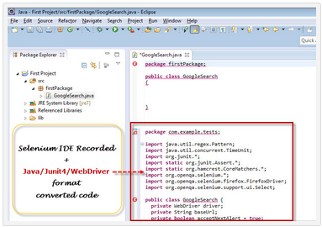

1. Now in the code you experience that there are two packages, first is “package firstPackage;” & second is the “package com.example.tests;”.   
   The Class is allow to declare only one package but the copied code is added new package. So copied package is not present in the Eclipse IDE, so let’s comment out the package name “package com.example.tests;”.

